REPORT ON

**VITAL SIGN MEASUREMENT SYSTEM**

Submitted by:

MUMMINENI CHAITANYA KUMAR

(PROV/BTECH-CSE/10-20/071)

Under the Guidance of:

**DR. HARINATH AIREDDY**



In Semester II of the Bachelor of Technology (2020-24)





INDEX

1. ABSTRACT.........................................................................................................................3
2. INTRODUCTION................................................................................................................3
3. OBJECTIVE.........................................................................................................................4
4. METHODOLOGY...............................................................................................................4
5. RESULTS …........................................................................................................................5
6. SCOPE OF THE WORK......................................................................................................5
7. CONTRIBUTION.................................................................................................................5
8. CONCLUSION.....................................................................................................................6
9. ACKNOWLEDGEMENT....................................................................................................6
10. REFERENCES.....................................................................................................................6

ABSTRACT

Consistent vital sign monitoring is critically important for early detection of clinical deterioration of patients in hospital settings. Mostly, nurses routinely measure and document the primary vital signs of all patients 2-3 times daily to assess their condition. to reduce nurse workload there by improve quality of patient care, a smart vital sign monitor named "VITAL SCOPE" for simultaneous measurement of vital signs was developed. Vital-Scope consists of multiple sensors, including a reflective photo sensor, thermopile, and medical radar, to be used in simultaneous pulse rate, SpO2, and body temperature monitoring within 10 s.

INTRODUCTION

* Vital signs are measurements of the body's most basic functions. The four main vital signs routinely monitored by medical professionals and health care providers include the following:
* Body Temperatures
* Pulse Rate
* SpO2(oxygen saturation in blood)

Vital signs are use full in detecting or monitoring, medical problems. Vital signs can be measured in a medical setting, at home, at the site of a medical emergency, or elsewhere.

OBJECTIVE

Your vital signs measure your body's basic functions. vital display a snapshot of what's going inside your body. They provide crucial information about your organs. Therefore, the importance of vital signs monitoring is that it allows medical professionals to assess your wellbeing.

METHODOLOGY

in hospital settings. Mostly, nurses routinely measure and document the primary vital signs of all patients 2‐3 times daily to assess their condition. To reduce nurse workload and thereby improve quality of patient care, a smart vital sign monitor named consistent vital sign monitoring is critically important for early detection of clinical deterioration of patients “Vital‐SCOPE” for simultaneous measurement of vital signs was developed. Vital-SCOPE consists of multiple sensors, including a reflective photo sensor, thermopile, and medical radar, to be used in simultaneous pulse rate, respiratory rate, and body temperature monitoring within 10 s

RESULTS

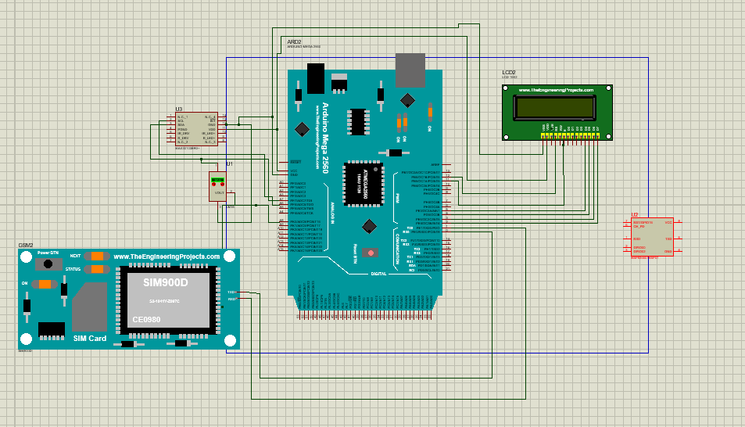

SCOPE OF THE WORK

In future, heart rate and SpO2can also be measured by plus oximeter along with SPO2 providing future functionality to the project. Also, different sensors like Blood pleasure sensor can be added to measure other parameters as well. Future, by integrating GSM with our project, we can send notification messages to a medical expert helping in immediate alert in case of emergency. provision of information regarding prescription and remainder for medicine in take can also be include.

CONTRIBUTION

Vital signs give you a baseline when a patient is healthy to compare to the patient's condition when they aren't healthy. Abnormalities in vitals can also be a clue to illness or disease that can be hurting the organ systems in the patient's body. Vital sign monitoring is a fundamental component of nursing care. We're taught in nursing school that a patient's pulse, respirations, blood pressure, and body temperature are essential in identifying clinical deterioration and that these parameters must be measured consistently and recorded accurately.

CONCLUSION

It measures the four important features of vital sign measurement system. There are four primary vital signs: body temperature,

pulse (heart rate),

SpO2(oxygen saturation in blood)

ACKNOWLEDGEMENT

I would like to thank DR. HARINATH AIREDDY for helping and providing moral support. They have extended support while making attachments. Testing was done and the "VITAL SIGN MEASUREMENT SYSTEM" machine worked successfully.

REFERENCES

* Encyclopaedia Britannica. Family. Papyrus Press, 1991; 46:276.
* Encyclopaedia Hydria‐Cambridge‐Ilion. Tesserae Epsilon Press
* YouTube
* Wikipedia